Project Design Phase Problem – Solution Fit Template

Date | 2 November 2025
Team ID | NM2025TMID04510
Project Name | Calculating Family Expenses using ServiceNow
Maximum Marks | 2 Marks

Problem-Solution Fit Template:
Manual family expense management is frequently laborious, prone to mistakes, and devoid of appropriate monitoring or classification systems. Many families find it difficult to keep precise records of their daily expenses, which results in inadequate budgeting and unforeseen spending. It is challenging to track family members' spending, analyze spending, and make wise financial decisions without a centralized system.
Goal:
• The project "Calculating Family Expenses using ServiceNow" offers an automated and effective way to handle and examine family financial information. We created linked tables, Family Expenses and Daily Expenses, that automatically update and summarize daily transactions using ServiceNow's platform. The system guarantees smooth tracking and aggregation of all expenses with features like auto-numbering, dynamic relationships, business rules for real-time adjustments, and form customisation.

Template:

Outcome / Impact:
- Enhanced accuracy and transparency in family expense records.
- Automated synchronization between daily and total expense tables.
- Reduced manual workload and faster expense summarization.
- A structured and scalable solution that can adapt to different family sizes.
Encourages responsible budgeting and informed financial decision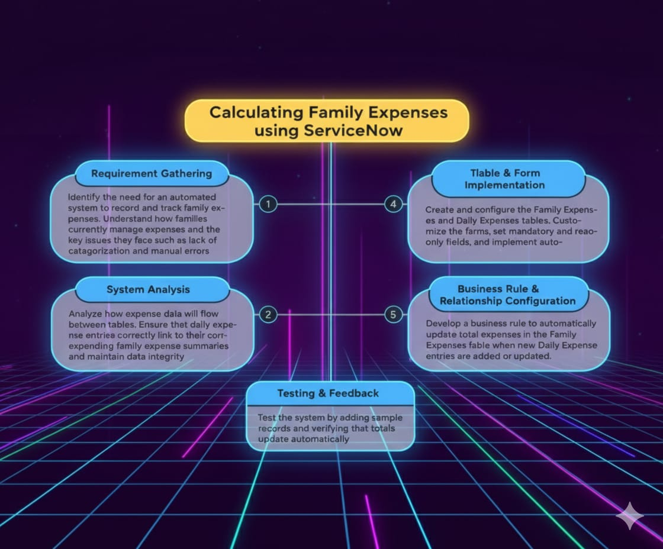
Outcome / Impact:
- Enhanced accuracy and transparency in family expense records.
- Automated synchronization between daily and total expense tables.
- Reduced manual workload and faster expense summarization.
- A structured and scalable solution that can adapt to different family sizes.
Encourages responsible budgeting and informed financial decision

